CUSTOM BOOK COVER ORDER FORM 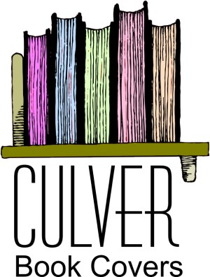

Customer Name: __________________________________________________
Contact Info (address, email, phone):
________________________________________________________________
________________________________________________________________
________________________________________________________________
Program/Specialty Book: __________________________________________
Ex: AA, NA, CA, GA, ACA, Al-anon, Nar-Anon, Bible, other
Book Title(s): ____________________________________________________
Book Size: Small Regular Large XLarge (Circle One)
Paperback or Hardback (Circle One)
Deluxe (Add Snap, Bookmark, Penholder) for Single Cover: YES or NO
Single, Double, or Triple Book Cover (Circle One)
Cover Material: Vinyl or LEATHER (Circle One)
Vinyl Colors: Blue, Red, Tan, Burgundy, Brown, Black, Green,
Purple, Pink, Nickel, Ocean Gray, Grey Mist (Circle Choice(s))
Leather Colors: Blue, Tan, Burgundy, Brown, Black, Pink, Coral (Circle Choice(s))
Quantity : ______________________________________________________
(Wholesale Customers: 100 Minimum, Add’l Cost for less than 100)
Date Needed/Date of Event: _____________________________________
Book Size: L x W x H(inches): ___________________________________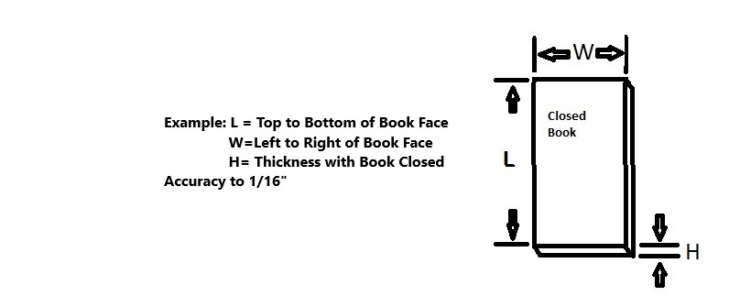Other Costs:
Screen(if needed): $85 (Customer provides artwork to size)
Ink Change: $25. We do single color silk screening. This
applies when multiple material covers are selected
and different ink colors are used(gold, silver, black).
COLOR Images: TBD, Call for Details.
Shipping & Handling, approx 7%

Prepay Required: ½ down and ½ upon completion
Allow 4 – 8 weeks for Delivery
Additional Comments or Details:
____________________________________________________
____________________________________________________
Email us: ce-bookcovers@charter.net
Fax: 541-244-1183 Phone Anne K or Ned C : 541-474-7655

